Assignment - 7

Gayatri Krishna | 21 BDA16 | 25/06/2022

What is stride, padding & pooling? Explain with an example.

1. The number of pixels shifted across the input matrix called the stride. The filters are moved to 1 pixel at a time when the stride is 1. The filters are moved to 2 pixels at a time when the stride is 2, and so on. With a stride of 2, convolution would function as shown in the figure below.

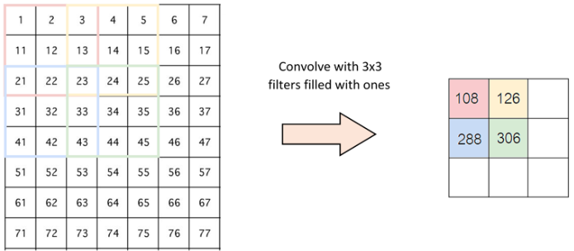

1. Padding is a concept that applies to convolutional neural networks since it describes the number of pixels that are added to an image during processing by a CNN's kernel. For instance, if the padding in a CNN is set to zero, then any additional pixels will have a value of 0. However, if the zero padding is set to 1, an additional one-pixel border with a pixel value of zero will be applied to the image.

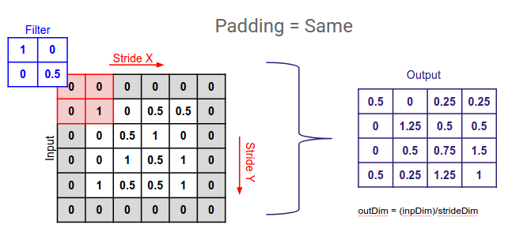

1. Pooling in CNN is the process of creating a backbone that gradually reduces the number of parameters in the network. The two most popular approaches are maximum pooling and average pooling.

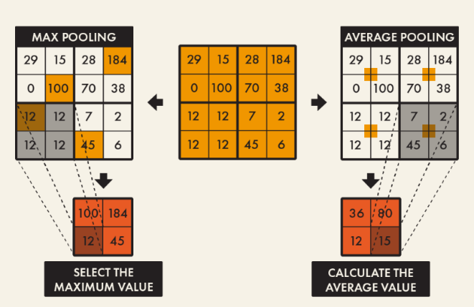

What is overfitting? How to overcome overfitting in an ML model?

1. A statistical modelling error called overfitting happens when a function is too closely matched to a small number of data points. Because of this, the model is only helpful in relation to its original data set and not in relation to any additional data sets.
2. Handling overfitting

* Reduce the number of elements in the hidden levels or remove layers to increase the network's capacity.
* Apply regularization, which entails increasing the loss function's cost for heavy weights.
* Use dropout layers, which will randomly set some characteristics to zero and erase them.